State Traffic Operations Plan
J. Database Requirements and Design

Wisconsin Department of Transportation
Bureau of Highway Operations

November 2004
Table of Contents

1.0 Introduction 1
1.1 Purpose 1
1.2 Scope 1
1.3 Overview 1
2.0 Process Requirements 2
3.0 Data Requirements 3
3.1 Traffic Operations Plan Data 3
3.2 Database Structure and Standards 4
4.0 User Interface Requirements and Design 5
4.1 System and Software Requirements 5
4.2 User Interface Requirements 5
4.3 User Interface Screen Designs 5
4.3.1 Login 6
4.3.1.1 Login Screen 6
4.3.1.2 Login Screen Description 6
4.3.2 WisDOT Traffic Operations Plan Home Page 7
4.3.2.1 WisDOT Traffic Operations Plan Home Page Screen 7
4.3.2.2 WisDOT Traffic Operations Plan Home Page Description 7
4.3.2.3 WisDOT Traffic Operations Plan Home Page Menu 8
4.3.3 Data Entry and Maintenance 8
4.3.3.1 Data Entry and Maintenance Screens Description 8
4.4 System Controls 9
5.0 Data Interface 9
5.1 Input Requirements 9
5.2 Output Requirements 9
6.0 Reports Requirements and Design 9
6.1 Report Requirements 9
6.2 Reporting Features 10
6.3 Report Design 10
7.0 Security Requirements 11
7.1 Access Level Requirements 11
7.1.1 User Groups 12
7.2 Audit Requirements 12
7.3 System Security Requirements 12
8.0 User Aids Requirements 12
9.0 Storage Requirements 13
9.1 Archive 13
9.2 Backup 13
10.0 Performance Requirements 13
11.0 Communication Requirements 13
11.1 Messaging 13
11.2 Transportation 13
12.0 System Architecture 13
12.1 Client 13
12.2 Server 14
12.3 Directory Structure 14
12.4 Testing Procedures 14

Acronyms

WisDOT Wisconsin Department of Transportation

- Introduction
This Requirements and Design Document is intended to define the requirements and desired design of the Wisconsin Department of Transportation (WisDOT) Statewide Traffic Operations Plan Web Site.
  - Purpose
The Requirements and Design Document serves as system definition blueprint throughout the software development life cycle. The purpose of this document is to ensure that the resulting system satisfies every requirement as stated herein and satisfies the intended objective set forth by this development effort. The set of requirements are intended to be correct, unambiguous, complete, consistent, verifiable, modifiable, and traceable throughout the life cycle software development process, and the design is intended to fulfill each one of these requirements. The intended audience for this document includes the WisDOT and the web site development contractor project team (URS Group, Inc.).
  - Scope
Name of developed system: WisDOT Statewide Traffic Operations Plan Web Site (hereinafter referred to as the “system”). The contractor shall create an Statewide Traffic Operations Plan web site to manage, store, and create reports for WisDOT. The system will be able to prioritize solutions to WisDOT’s traffic operations goals, objectives, and actions. Also, projects will be created for solutions. The system will be designed as an intranet solution, a web application, which will reside at WisDOT.

The system shall have several levels of authorization to system’s data, including system administrative users, the main facility users, and district office users who need access to the reports.
  - Overview
This Requirements and Design Document provides details of the system in terms of specific requirements and desired design encompassing hardware/software, communication, security, and human interfaces. It also defines features that the system must provide. This information is defined and documented in the following sections of this document:

- Processes: the definition of the unique business rules, calculations, and other functional needs specific to the scope of this system.

- Data: the data dictionary definition outlining the data tables and fields required in support of the scope of this system.

- User Interface: the definition of the system screen (form) hierarchy, screen layout(s), and navigation tools that the users will interact with when using the system.

- Data Interface: the definition of data input and output requirements that the system needs to interact with.
- Reports: the definition of output requirement(s) and format(s) needed to meet hard copy and digital (print to file) output requirements.

- Security: the definition of the security requirements of the system.

- User Aids: the definition of any user aid requirements including system documentation, on-line help and tool-tip functionality.

- Storage: the definition of the data archive and backup requirements of the system.

- Performance: the definition of any response time requirements as well as system functionality requirements related to processing response time.

- Communication: the definition of any networking communications requirements as well as interactive messaging requirements.

- System Architecture: the definition of the software and hardware requirements that the system needs for operation, maintenance, and testing procedures.
- Process Requirements
The system will be able to prioritize solutions to WisDOT’s traffic operations plan goals, objectives, and actions. To accomplish this, the system will have the following scope-specific process requirements.
- WisDOT traffic operation plan goal categories and goals must be maintained.

- Objectives and their performance measures and criteria must be maintained for the established goals.

- Actions to meet those objectives must be maintained. Actions may no longer need to be maintained. Further discussion is needed.

- Business plan solutions must be maintained and assigned to actions.

- The Traffic Operations Functional Inventory must be maintained and assigned to solutions.

- Solutions must be scored and prioritized for solution priority and criteria categories.
- Projects must be maintained and assigned to solutions.

- Reports must be run and viewed in support of the system’s processes. Reports will be viewed by the administrative users and reports only users.
- Data Requirements
  - Traffic Operations Plan Data
The following Traffic Operations Plan data will be required:

- Goal Categories: The goals are separated into categories such as safety, mobility, reliability, customer service, and efficiency.

- Goals: The goals of the Traffic Operation Plan need to be maintained.

- Objectives: The objectives of each goal need to be maintained. There can be multiple objectives per goal.

- Performance Measures and Criteria: The objectives have associated performance measures and criteria. There can be multiple performance measures and criteria per objective.

- Actions: There are many actions that must be accomplished for each objective, and they will be maintained and associated with multiple objectives. Actions may no longer be necessary to maintain for solutions. Further discussion is needed.

- Solutions: The business plan solutions need to be maintained. Solutions can satisfy multiple actions. Actions may no longer be necessary to maintain for solutions. Further discussion is needed.

- Functions: The Traffic Operations Functional Inventory needs to be maintained. Functions are associated to solutions. Multiple functions may be associated to one solution and multiple solutions may be associated to one function.

- Function Categories: The functions in the Traffic Operations Functional Inventory are separated into categories such as Planning and Design.

- Solution Priorities: In order to be able to prioritize solutions, there are priority and criteria solution categories and subcategories. They serve as a means to score solutions in order to prioritize the Traffic Operations Plan.

- Solution Scores: The solution scores need to be maintained as a means to prioritize the Traffic Operations Plan.

- Projects: Projects need to be maintained and associated with solutions. Multiple projects may be associated to one solution and multiple solutions may be associated to one project.

  - Database Structure and Standards
All data requirements for this system are defined in a system database structure. The system database structure or logical and physical entity relationship diagrams will be developed using the CASE tool. The CASE tool provides the capability of building and managing the database structure by connecting to the relational database. The following is a physical entity relationship diagram necessary for the system.
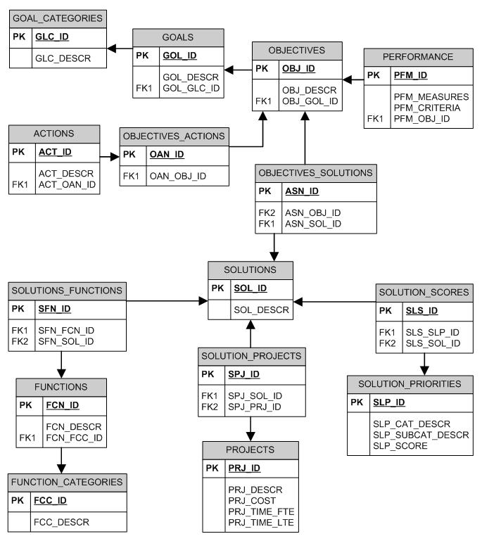
- User Interface Requirements and Design
  - System and Software Requirements
The system will be developed to operate within the following environment:
- Screen resolution of 800 × 600 or higher
- Monitor color depth of at least thousands of colors (16-bit color)
The system will be developed to use the following Web browser software:
- Microsoft Internet Explorer 5.0 or higher
  - User Interface Requirements
The system will have the following scope-specific user interface requirements.

- Traffic Operations Plan Data: User interface screens will be required to manage, store, and create reports for the Traffic Operations Plan for WisDot. The system should be capable of performing additions, modifications, and deletions of this data.
  - User Interface Screen Designs
Users will be able to access the system from an Internet-accessible browser. Users will then log into the system. Each user will then see the WisDOT Traffic Operations Plan home page containing (on the left) those menu options to which each particular user has access rights. Upon selection of a menu option (on the left), an action will be initiated (adding and editing data, reports, etc.). The user will see the results of this action in the content portion (right of the menu). From here users will be able to select and operate the various system functions available to them, which will depend on the action initiated by a menu option. The user interface screen design for the system is illustrated in the following sections.

Login

Login Screen

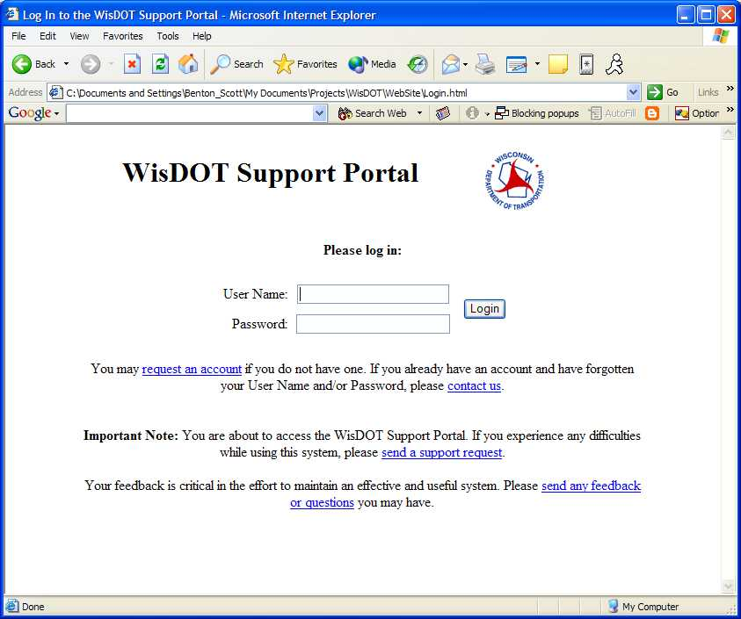

Login Screen Description
Users will be able to access the system from an Internet-accessible browser. Users will then log into the system using this Login screen.

WisDOT Traffic Operations Plan Home Page

WisDOT Traffic Operations Plan Home Page Screen

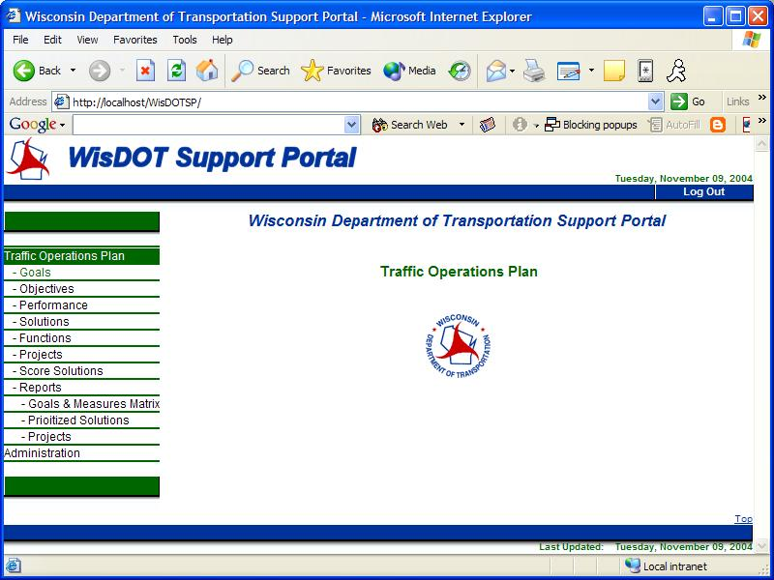

WisDOT Traffic Operations Plan Home Page Description
After logging in, each user will then see the WisDOT Traffic Operations Plan home page containing (on the left) those menu options to which each particular user has access rights. Upon selection of a menu option (on the left), an action will be initiated (adding and editing EMS data, EMS reports, etc.). The user will see the results of this action in the content frame (to the right of the menu options). From here users will be able to select and operate the various system functions available to them, which will depend on the action initiated by a menu option.

WisDOT Traffic Operations Plan Home Page Menu
The system will have the following menu options. The menu options available are dependent on a user’s access rights.

- Traffic Operations Plan
- Goals
- Objectives
- Performance Measures and Criteria
- Solutions
- Functions
- Projects
- Score Solutions
- Prioritized Solutions Report
- Goals and Measures Matrix Report
- Projects Report

Data Entry and Maintenance

Data Entry and Maintenance Screens Description
When a user chooses a menu item from the menu on the left, the appropriate screens will be displayed in the content area right of the menu. It will contain the screen title and user directions, if necessary, and it will give the user the ability to add, edit, delete, and/or view input for data entry and maintenance screens. The following data entry and maintenance screens have been identified.

- Goals: A set of screens to maintain goals will be needed. A list of the goals will be able to be viewed. These goals and their attributes can be added, edited, or deleted, if necessary.

- Objectives: A set of screens to maintain objectives will be needed. A list of the objectives will be able to be viewed. These objectives and their attributes can be added, edited, or deleted, if necessary.

- Performance Measures and Criteria: A set of screens to maintain performance measures and criteria will be needed. A list of the performance measures and criteria will be able to be viewed. These performance measures and criteria and their attributes can be added, edited, or deleted, if necessary.

- Solutions: A set of screens to maintain solutions will be needed. A list of the solutions will be able to be viewed. These solutions and their attributes can be added, edited, or deleted, if necessary.

- Functions: A set of screens to maintain functions will be needed. A list of the functions will be able to be viewed. These functions and their attributes can be added, edited, or deleted, if necessary.

- Projects: A set of screens to maintain projects will be needed. A list of the projects will be able to be viewed. These projects and their attributes can be added, edited, or deleted, if necessary.

- Score Solutions: A set of screens to score solutions will be needed. A list of the solutions will be able to be viewed. These solutions can then be scored in order to set priorities.
  - System Controls
The system will be comprised of a series of data entry screens utilizing common Web-style user interface elements and controls. The user will be able to advance from one user interface element to another using the Tab key on the keyboard or by pointing and clicking the desired control (tab, button, etc.) with the mouse.

The system screen design will include discrete and consistently located sections for displaying system navigation and data entry screens.
- Data Interface
  - Input Requirements
The system will have the following scope-specific data interface input requirements.

- Traffic Operations Plan Data: Before using the system, the Traffic Operations Plan data such as Goals, Objectives, Actions, etc. need to be input into the system.
  - Output Requirements
The system will have the following scope-specific data interface output requirements.

- None required at this time.
- Reports Requirements and Design
  - Report Requirements
The system will have the following scope-specific report requirements.

- Prioritized Solutions Report: A Prioritized Solutions report will be required. This report will contain the solution priority categories and subcategories, a list of the solutions, and a score for each solution priority per solution.

- Goals and Measures Matrix Report: A Goals and Measures Matrix report will be required. This report will contain Goals, Objectives, Performance Measures, and Criteria for each Goal Category.

- Projects Report: A Projects Report will be required. This report will contain goals, objectives, their solutions information, and associated projects.
  - Reporting Features
Each report will be able to be viewed on the screen.

Each report will be able to be printed on any attached printer.
  - Report Design
The design of the required standard reports is as follows:

- Prioritized Solutions Report: The following is an example, taken from a spreadsheet file (“Prioritized Solutions v 0.2.xls”) of a Prioritized Solutions Report.
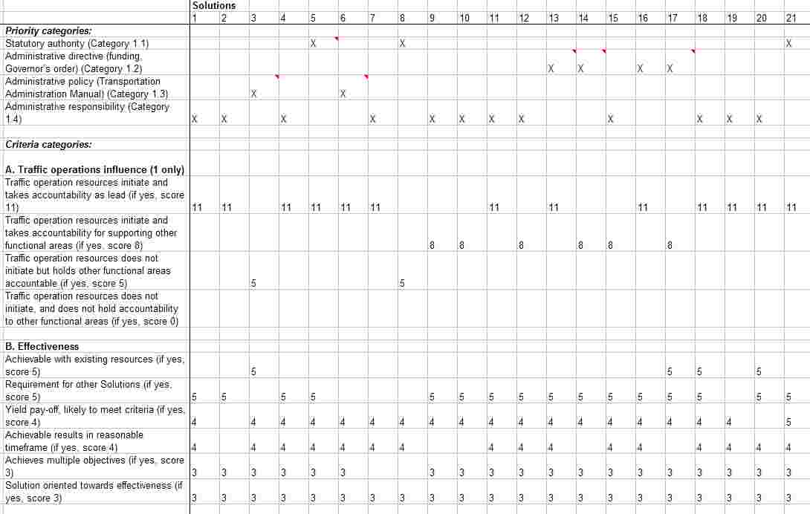
- Goals and Measures Matrix Report: The following is an example, taken from a spreadsheet file (“Goals and Measures Matrix v 2.2 070204.xls”) of a Goals and Measures Matrix Report.
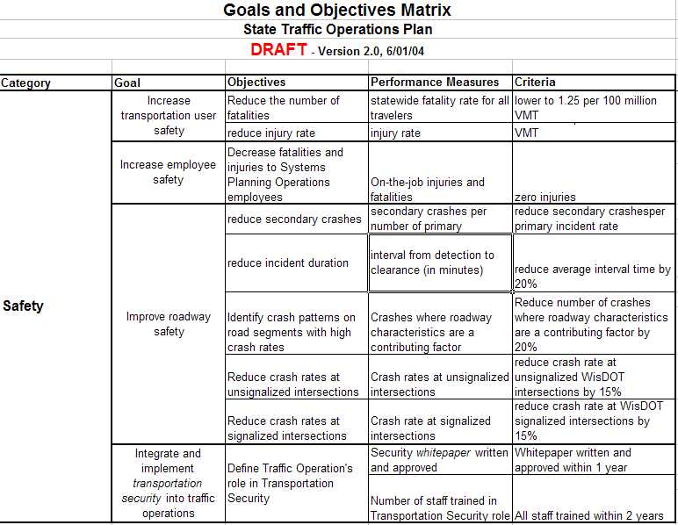
- Projects Report: A Projects Report will be required. This report will contain goals, objectives, their solutions information, and associated projects.
- Security Requirements
  - Access Level Requirements
The system will have the following scope-specific security access level requirements.

- The users of the system will be system administrators, main facility users, and district office users. Main facility users will work directly with the Traffic Operations Plan data including scoring and prioritizing solutions. District office users only need access to the reports.

- User groups will only be able to see menu options for which they have privileges and access.

- The user groups of the system are as follows: System Administrator, Data Users, and Reports Users.

User Groups

System Data
System Administration | Data Entry and Maintenance | Reports | User Group | Users
X | X | X | System Administrator | System Administrator from URS Group, Inc. and WisDOT
 | X | X | Data Users | Data entry and maintenance users from the main facility.
 |  | X | Reports Users | District office users.

User IDs and passwords are distributed based on the user group. Administrator users will be given individual User IDs and passwords to gain access to the system.
  - Audit Requirements
The system will have the following scope-specific audit requirements.

- The system must be able to maintain data for the current year. At this time, subsequent year’s data will start with a new active system database to prevent previous year’s data from being lost.
  - System Security Requirements
The system will have the following scope-specific system security requirements.

- The system will follow WisDOT’s security requirements since it will be hosted internally by WisDOT.
- User Aids Requirements
The system will have the following scope-specific user aids requirements.

- The system will have tool-tips for user interface controls where possible.
- Storage Requirements
  - Archive
The developed system will store all data in the active system database for the current year. At this time, subsequent year’s data will start with a new active system database to prevent previous year’s data from being lost.
  - Backup
Backups of data will be performed via the system administration function of the hosting data center for the system at WisDOT.
- Performance Requirements
The developed system will indicate the status to the user during all processing functions. For example, the cursor will become an hourglass and a message will appear in the status bar.

The database will be optimized such that queries and calculations will be performed on the server. Therefore, system response time will be limited only by the connection speed of the remote user.
- Communication Requirements
  - Messaging
The developed system will not require the use of messaging at this time.
  - Transportation
The developed system will use the Transmission Control Protocol/Internet Protocol to communicate with the network.
- System Architecture
The developed system will be a thin client application, allowing the client portion of the system to operate on the user’s PC through a browser application and the server portion of the system to operate on a hosted server at WisDOT.
  - Client
The client portion of the system will be developed to operate on IBM-compatible PCs with an Intel processor running a Windows 9x and above operating system.

The client portion of the system will be a 32-bit application developed in Microsoft Active Server Pages (ASP).
  - Server
The server portion of the system will be developed to operate on IBM-compatible PCs with an Intel processor running a Windows 9x and above operating system.
The server portion of the system (database) will be developed using computer-aided system engineering (CASE) tools to enable the use of a variety of relational database tools. Microsoft Access 2000 will be used as the database.
  - Directory Structure
A directory structure will be used by the development team to maintain standards across the development, test, and production environments. This directory structure will be provided to WisDOT upon moving the system to WisDOT’s hosting environment.
  - Testing Procedures
The system will be created in a development client and server environment. There are existing procedures in place to transfer the system from the development environment to a test environment. Once system testing has occurred, there are existing procedures in place to transfer the system from the test environment to the production environment. Additional procedures will be needed to transfer the system from URS Group, Inc. to WisDOT.

