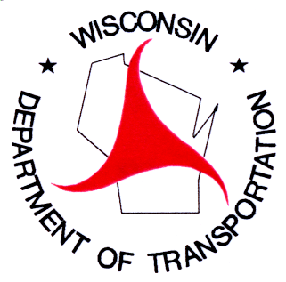
WisDOT Traffic Operations Sketch Planning
Early Activities: National Best Practices Scan
August 24, 2006

CALL LIST

State DOT and Regional MPOs selected for National Best Practices Scan
- AZDOT | - CalTrans
- FDOT | - MetroPlan
- Maryland SHA | - Kansas City MARC
- Utah DOT | - Hampton Roads HRPDC
- Washington State DOT | - Illinois DOT
- Oregon DOT | - Tennessee DOT
- RIDOT | - NYSDOT
- PennDOT | - SEMCOG

